
CHESS CONGRESS DRUSKININKAI’ 2014
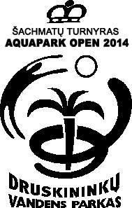
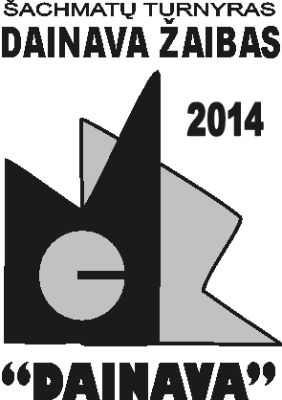
PROGRAMME
- FIDE trainer seminar January 17-19, 2014
- Blitz Chess Tournament “Dainava”: January 17, 2014
- Rapid Chess Tournament “ Druskininkai Rapid Open”: January 18-19, 2014
- Rapid Chess Tournament for children “Aquapark Open”: January 18-19, 2014
- IM norm tournament 17-22, 2014
Organiser: IO Jonas Sidabras jonas.sidabras@gmail.com,, Sports and art club “Juoda balta” (“Black White”) http://www.juodabalta.org
Sponsors:   |  |  |  | 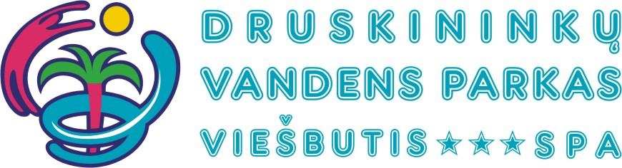 |  |  |  |  |  |  |  |  |  |  |  |  |  |  |  | 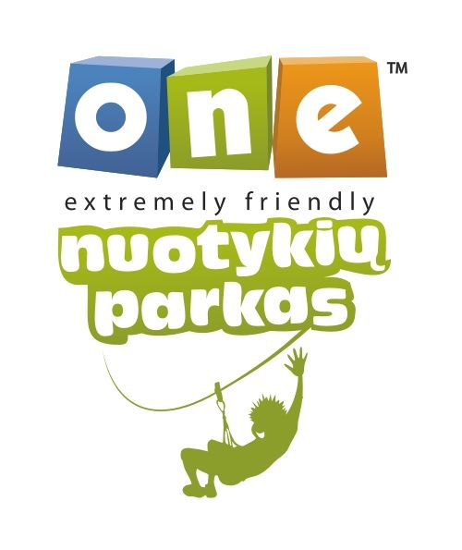
Date | Event |  | Venue |  |  | Participants |  | System/  rounds | Time control | Arrival before |  | Round 1 |  |  |  | Entrance fee | The prize fund allocated for all events is equivalent to 5000 LTL
ARRIVAL Jan. 17, 2014
Jan. 18-19, 2014 | FIDE trainer seminar |  | “Dainava“ Center,  22 Maironio Str |  | Coaches |  |  | seminar |  |  | Jan. 17, 2014 |  |  |  | by 25Dec -200eur,After 25 Dec-250e |  | FIDE Trainer seminar certificate
 |  |  |  |  |  |  |  |  |  |  | According to the seminar program
Jan. 17-22, 2014 | IM norm tournament |  |  |  | Adults |  |  | r/r |  |  | Jan. 17, 2014 |  |  |  | By ELO |  | Cup, diploma
Jan. 17, 2014 | Blitz  Dainava |  |  |  | Children adults |  |  | swiss  9 | 3 min. + 2 sek. | Jan. 17, 2014 |  |  |  |  |  | 3EUR  10 LTL | Prize fund according to the number of participants: Ist prize not less than 150 lt. + Body Detoxication procedure (min. number – 30 players)
 |  |  |  |  |  |  |  |  |  | 6.00 p.m |  | 7.00 p.m. |  |  |  | 3EUR  10 LTL
Jan. 18-19, 2014 | Druskininkai rapid  open |  |  |  | Adults and young adults |  |  | swiss  9 | 25 min.  + 10sek. | Jan. 18, 2014 |  |  |  |  |  | 35 LTL  GM,WGM, IM,WIM - free | Ist place prize -500 LTL, II-250 LTL, III-200 LTL, IV-150 LTL, V-100 LTL, VI-VIII – individual bathhouse programs, (min. numbers - 40 players); Other prizes: among women individual bathhouse program + 100 LTL, individual bathhouse program +100 LTL and other special prizes.I-III places within the juniors born 1998-99 and 1996-97 and the best among girls. Prizes by AquaPark, One and Labas, Adventure Park.,
 |  |  |  |  |  |  |  |  |  | 8.30 a.m |  | 10.00 a.m |  |  |  | 35 LTL  GM,WGM, IM,WIM - free
Jan. 18-19, 2014 | Aqua  park  open |  |  |  | Born 2000 and younger |  |  | swiss  9 | 25 min.  + 10sek. | Jan. 18, 2014 |  |  |  |  |  | 35 LTL  discount 10 LTL staying „Dainava“  „Regina“ | Prizes by Druskininkai AquaPark , One and Labas Adventure Parks will be awardet to I-III places within the juniors born 2001-01, 2002-03, 2004-05, 2006-2007, 2008 and younger; best among girls. Special prizes.
 |  |  |  |  |  |  |  |  |  | 8.30 a.m |  | 10.00 a.m |  |  |  | 35 LTL  discount 10 LTL staying „Dainava“  „Regina“
CLOSING CEREMONY Jan. 19, 2014, 3.00 p.m.
Hotel |  | Accommodation. Price. Druskininkai sity fee 2 lt person/night |  |  |  |  |  |  |  |  |  |  |  |  |  |  |  | Meals |  |  |  |  | Price
Dainava **  22 Maironio Str |  | Jan. 17-19, 2014 (2 nights)/ per person: main building - single (50eur), double, triple (40eur); wooden building – single (43eur), double (35 eur), triple and quadruple (32eur) rooms |  |  |  |  |  |  |  |  |  |  |  |  |  |  |  | Buffet meals (dinner 15lt,breakfast 12lt,lunch 16lt)  Children’s meals/portion (dinner ,breakfast,lunch ) |  |  |  |  | 13 eur  10 eur
Regina*** |  | Jan. 17-19, 2014 (2 nights)/ room price: single - 95eur, double - 60 eur, suite - 180eur
Conditions |  | Applications form and reservation to be submitted before Jan. 2, 2014 at jonas.sidabras@gmail.com . Entrance fees to be transferred before Jan. 14, 2014 to IBAN LT647044060006885752, company code 302324139, Sports and art club “Juoda balta” or paid cash before Jan. 17, 2014. If submitted and paid later, the entrance fee increases 10 LTL. . Information +37068682025. All the travel, accommodation and other related expenses are to be paid by the participants or their sending organization. The Congress organizer retains the right to make all the necessary changes.
Special rates for the Congress participants at Druskininkai Aquapark www.akvapark.lt/, Health Resort“Druskininkų gydyklos” www.gydykla.lt/, „One Adventure Park“ www.onenuotykiuparkas.lt/

Application Form |  | Federation  Title | FIDE  Rating | Date of birth | e-mail  phone No | Event |  |  |  |  | Accommodation | Meals | Player/ Accomp.  Person  Comment
No | Surname, Name |  |  |  |  | Blitz  Dainava | Druskininkai  open | Aquapark open | FIDE  seminnar | IM tournament | Dainava**  Regina*** | 13eur/  10eur | Player/ Accomp.  Person  Comment
1.
2.
3.
4.

